Resume
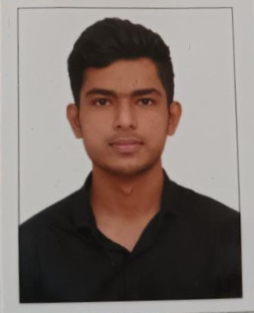
Name. - Kunal Deepak Jadhav
Mobile no - 7719049889
Email ID - kunaldjadhav16@gmail.com
Address - Makhmalabad, Nashik-03
Career objective/ Brief overview :
Seeking a challenging position in a reputed organization where I can learn new skills, expand my knowledge and leverage my learning.

Academic background :
1. 2017- 2021 Diploma in Electrical Engineering (MSBTE)
Guru Govind Singh college of Engineering ,Nashik
70.68%
2. 2016-2017 Secondary school certificate (SSC) Maharashtra board
Aadarsh Madhyamik vidyalaya, CBS, Nashik
57.60%

Professional skills :
- Good communication skills (verbal, written)
- Proficient in MS Excel, MS Word, MS PowerPoint
- Well organized, details oriented
- Proficient in C+ Language

Project work/ internship :
- Company. - Nashik Thermal Power Station
Designation -. Intern

- Company. -. Snjoshi Consultants Pvt. Ltd, Pune
Designation - Trainee
Duration - 1 month (June 2020- July 2020)
Project.
1. Home Automation using Arduino
Personal details :
- Gender -. Male
- DOB. - May 16, 2002.
- Marital status - unmarried
- Known languages - English, Hindi, Marathi
- Current address - Plot no.20, Kuldeep, Mahadev Colony,Lane no 1, Makhmalabad, Nashik-422003
- Phone no. - 7719049889

Declaration:
I hereby declare that, all the above information is true to the best of my knowledge.

Place : Nashik. Kunal Deepak Jadhav
Date. :

